**Spreadsheet Project:**

**Zomato Restaurants Analysis**

**Objective Questions**

1.What is the total no. of tables present in the data?

Ans. There are 2 Tables

2.What is the total no. of attributes present in the data?

Ans. There are 22 Attributes in raw data.

3.How many categorical columns are there in the data?

Ans. It includes 13 categorical columns: Restaurant_name, Country_code, City, Locality, Cuisines, Currency, Has Table Booking, Has Online Delivery, Is Delivering Now, Switch Menu Order, Price Range, and Date of Opening.

4.The data consists of some inconsistent and missing values so ensure that the data used for further analysis is cleaned.

Ans.

* Duplicate entries have been removed for data accuracy.
* Extra white spaces were trimmed using data cleaning functions to ensure consistency.
* The Datekey field has been converted into a date format for easier time-based analysis.
* Currency symbols have been separated into a dedicated column for clarity.
* The average cost for two, originally in various currencies, has been standardized to INR for uniform comparisons.
* Country names from the country category have been extracted and added to the raw data sheet.
* Missing values in the cuisines column were filled based on the popularity of cuisines in each locality, and the restaurant names were reviewed to make informed guesses on likely cuisines.

5.Using the LookUp functions, fill up the countries in the original data using the country code

Ans. Approach used: The VLOOKUP function was used to populate the country names in the Raw Data sheet based on the country codes found in the Country Description sheet.

Column E now displays the country names, extracted using VLOOKUP from the Country Description worksheet.

Formula: =VLOOKUP($C2, 'country description'!$A$2:$B$16, 2)

6.Create a table to represent the number of restaurants opened in each country.

Ans.

| **Countrty_Name** | **Number of Restaurants** |
| --- | --- |
| Australia | 24 |
| Brazil | 60 |
| Canada | 4 |
| India | 8652 |
| Indonesia | 21 |
| New Zealand | 40 |
| Philippines | 22 |
| Qatar | 20 |
| Singapore | 20 |
| South Africa | 60 |
| Sri Lanka | 20 |
| Turkey | 34 |
| United Arab Emirates | 60 |
| United Kingdom | 80 |
| United States of America | 434 |
| **Grand Total** | **9551** |

**Approach Used**: Used a **Pivot Table** to count the total restaurants per country.

India has the highest count of restaurants, with **8,652** entries, indicating a high market presence.

7.Also, the management wants to look at the number of restaurants opened each year, so provide them with something here.

Ans.

| **Year** | **No Restaurants opened** |
| --- | --- |
| 2010 | 1080 |
| 2011 | 1098 |
| 2012 | 1022 |
| 2013 | 1061 |
| 2014 | 1051 |
| 2015 | 1024 |
| 2016 | 1027 |
| 2017 | 1086 |
| 2018 | 1102 |
| **Grand Total** | **9551** |

**Approach Used**: Used a **Pivot Table** with Year as rows to display the number of restaurant openings per year.

Restaurant openings show growth trends, with the highest count in recent years.

8.What is the total number of restaurants in India in the price range of 4?

**Approach Used**: Applied **COUNTIFS** to filter for restaurants in India with a price range of 4.

Formula: =COUNTIFS('Raw Data'!$D$2:$D$9552, "India", 'Raw Data'!$R$2:$R$9552, "4")

India has **388** restaurants in the highest price range, showing demand for premium options.

9.What is the average number of voters for the restaurants in each country according to the data?

Ans.

|  |  |
| --- | --- |
| **Countrty_Name** | **AVERAGE of Votes** |
| Australia | 111.417 |
| Brazil | 19.617 |
| Canada | 103.000 |
| India | 137.213 |
| Indonesia | 772.095 |
| New Zealand | 243.025 |
| Philippines | 407.409 |
| Qatar | 163.800 |
| Singapore | 31.900 |
| South Africa | 315.167 |
| Sri Lanka | 146.450 |
| Turkey | 431.471 |
| United Arab Emirates | 493.517 |
| United Kingdom | 205.488 |
| United States of America | 428.221 |

Approach used:Pivot table has been used to show the average number of voters for the restaurants in each country.

10.Calculate the average rating for all the restaurants that have price_range < 4 and provide online delivery. Use only the “IF” function, Logical Operators, and Aggregation functions to solve this problem.

Ans. **Approach Used**: Applied **IF** with logical operators to find the average rating for qualifying restaurants.

Formula: =AVERAGE(ARRAYFORMULA(IF(AND((T3:T9553<4),(Q3:Q9553="Yes")),Z3:Z9553,"")))

The average rating is **3.27381151**.

11.Using Conditional formatting highlight the rows of restaurants that are located in the countries or cities that you’ve suggested to the management for opening new restaurants.

Ans. **Approach Used**: Used **Conditional Formatting** to highlight rows with recommended countries like Indonesia Philippines Qatar and Turkey. Formula: **=and($E2="Indonesia",$E2="Philippines" ,$E2="Qatar",$E2="Turkey")** Highlighted targeted cities, making analysis more efficient.

12.Create a new customized price column that consists of the abbreviation/symbol of the currency along with the Average_cost_for_two value.

Ans. **Approach Used**: Used **XLOOKUP** to retrieve currency symbols and concatenated with **Average_cost_for_two.**

**Formula: =XLOOKUP($E2, 'country description'!$B$2:$B$16, 'country description'!$C$2:$C$16) & " " & W2**

13.How can you create an array formula in Excel or Google Sheets to count the number of restaurants listed that do not offer online delivery, are in the lowest price range, and have an average cost for two people less than or equal to 250 Indian Rupees?

Ans. **Approach Used**: Applied **ARRAYFORMULA** to count qualifying restaurants in Google Sheets.

Formula: =ARRAYFORMULA(COUNTIFS('Cleaned data'!I:I, "No", 'Cleaned data'!L:L, 1, 'Cleaned data'!P:P, "<=250"))

Found **1,676** restaurants in this category, indicating a substantial budget segment.

**Subjective Questions**

1. Suggest a few countries where the team can open newer restaurants with lesser competition. Which visualization/technique will you use here to justify the suggestions?

Ans. **Approach Used**: Based on the graph, I recommend opening new restaurants in the following countries with lower competition:

* **Indonesia**
* **Philippines**
* **Qatar**
* **Turkey**

These countries have an average restaurant rating above 4, combined with a restaurant count under 35, indicating a favorable balance of high customer satisfaction and low competition. With fewer restaurants and strong ratings, these markets present promising opportunities for new openings.

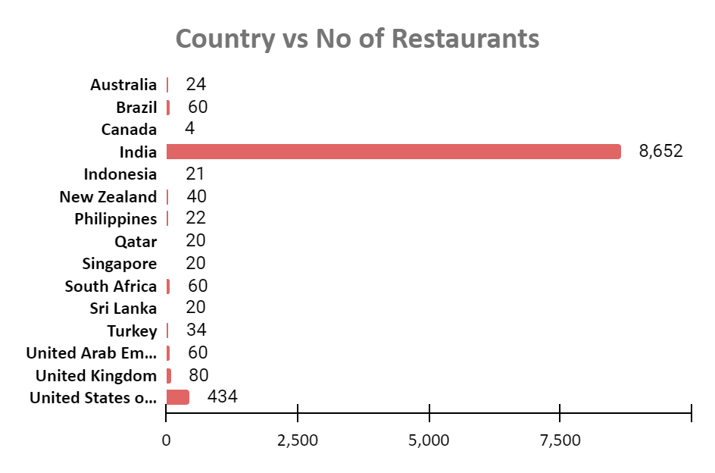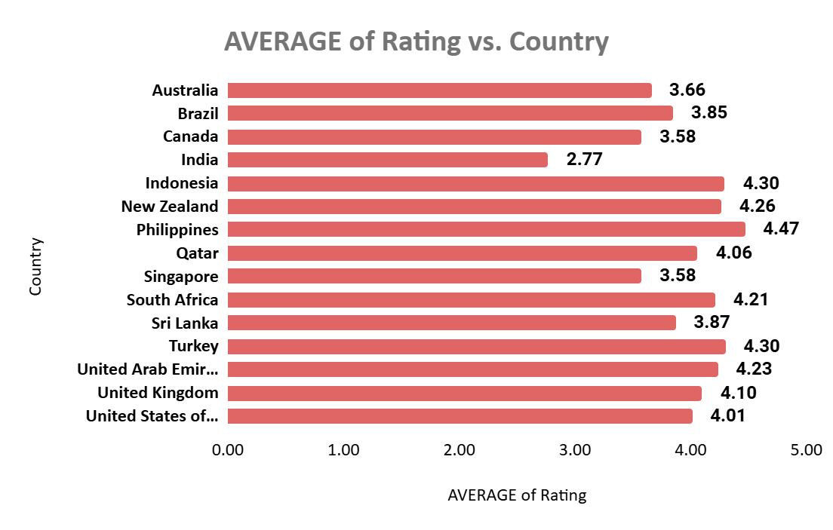

**Insights**:

**High Average Ratings**: Indonesia, Philippines, Qatar, and Turkey each have an average restaurant rating above 4, reflecting positive customer perceptions and a strong preference for quality dining experiences.

**Low Number of Restaurants**: With fewer than 35 restaurants in each country, competition is relatively low, creating a favorable environment for new entrants and highlighting an opportunity to fill a market gap.

**Consumer Demand**: The combination of high ratings and limited competition suggests strong demand for new dining options, allowing new establishments to tap into the existing positive consumer sentiment.

**Recommendations**:

**Market Research**: Conduct in-depth research in each country to understand local dining preferences, food trends, and cultural influences, and adapt restaurant concepts to match these insights.

**Pilot Locations**: Begin with one or two pilot locations in each country to test the market. Use feedback from these initial locations to fine-tune offerings before a broader expansion.

**Partnerships**: Explore partnerships with local businesses or chefs to increase authenticity and appeal. Collaborating locally can also help navigate regulatory requirements and cultural expectations more effectively.

1. Come up with the names of States and cities in the suggested countries suitable for opening restaurants.

Ans. **Approach Used**: Based on the table, it’s evident that the selected countries for new restaurant openings currently lack food delivery options. Since Zomato’s core service is food delivery, these cities provide an opportunity to establish new restaurants with the potential to add delivery services as the market evolves.

**Insights**:

* **Lack of Delivery Options**: The absence of online delivery services in these cities presents an opening to meet market demand initially through dine-in experiences, with the flexibility to expand to delivery as the demand grows.
* **Emerging Markets**: Cities in countries like the Philippines and Indonesia are undergoing rapid urbanization and economic growth, making them promising locations for new restaurant ventures.

**Recommendations**:

* **Focus on Dine-In Experience**: With limited online delivery, prioritize creating an exceptional dine-in experience featuring a unique ambiance, quality service, and engaging elements that encourage repeat visits.
* **Research and Feedback**: Regularly conduct market research and collect customer feedback to adapt menus and services, ensuring offerings stay aligned with changing customer preferences.

| *Country* | *City* | *Has_Table_booking* | *Has_Online_delivery* |
| --- | --- | --- | --- |
| Indonesia | Bandung | No | No |
|  | Bogor | No | No |
|  | Jakarta | No | No |
|  | Tangerang | No | No |
| Philippines | Mandaluyong City | No | No |
|  | Pasig City | No | No |
|  | Quezon City | No | No |
|  | San Juan City | No | No |
|  | Santa Rosa | No | No |
|  | Taguig City | No | No |
| Qatar | Doha | No | No |
| Turkey | Ankara | No | No |
|  | ÛÁstanbul | No | No |

1. According to the countries you suggested, what is the current quality regarding ratings for restaurants that are open there?

Ans. **Approach Used**: The pivot table and stacked column chart below reveal that restaurant ratings generally fall within the 3-5 range, indicating that current quality is relatively high across selected countries.

**Insights on Current Restaurant Quality**:

**Overall Positive Ratings**: Many restaurants in each country have ratings between 4-5, highlighting a strong presence of high-quality dining options.

**Indonesia**: 17 out of 23 restaurants are rated 4-5.

**Philippines**: 21 out of 24 restaurants are rated 4-5.

**Qatar**: 11 out of 23 restaurants are rated 4-5.

**Turkey**: 30 out of 36 restaurants are rated 4-5.

**Strong Performance in Turkey**: Turkey stands out with a high number of restaurants in the 4-5 range, suggesting a well-established dining scene with discerning customer preferences.

**Room for Improvement**: Although most restaurants in these countries have favorable ratings, a notable portion in the 3-4 range, especially in Qatar and Indonesia, indicates opportunities for enhancing quality and standing out from the competition.

**Recommendations**:

**Leverage High Ratings**: Use the strong ratings as a marketing advantage to position new restaurants as top-quality dining options. Highlighting popular, well-rated local favorites can help attract customers.

**Focus on Quality**: New restaurant concepts should emphasize quality, excellent service, and unique dining experiences to align with the positive reputation of existing establishments.

**Address Gaps in Lower Ratings**: Review restaurants with ratings between 3-4 to understand common challenges. These insights can help new restaurants avoid similar issues, such as inconsistent service or limited menu options.

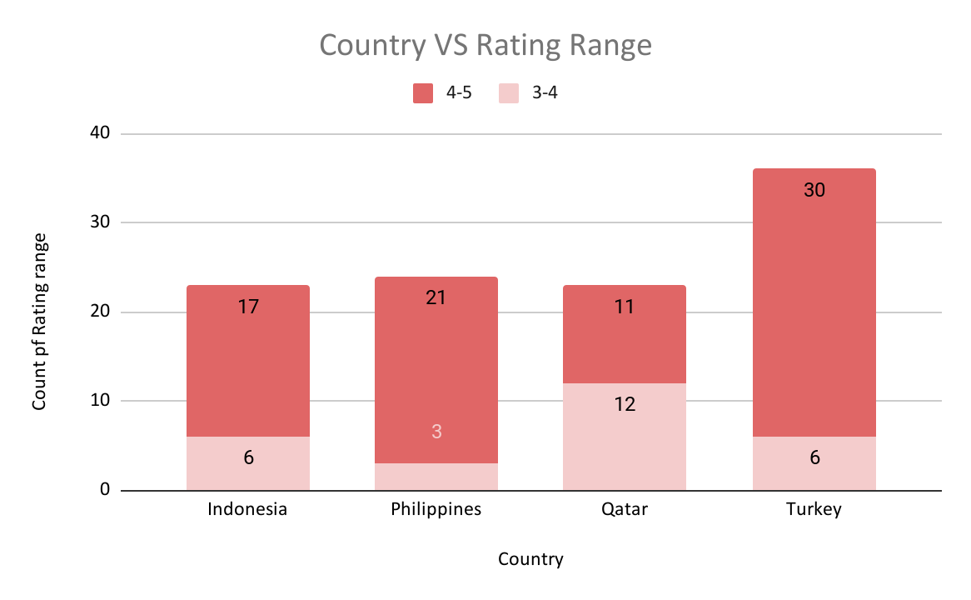

1. Also, what is the current expenditure on food in the suggested countries, so we can keep our financial expenditure in control?

Ans. **Insights on Current Food Expenditure**:

**Diverse Spending Patterns**:

* **Philippines**: With an average expenditure of ₹2,394, this market is moderately priced, suggesting potential for mid-range to premium dining experiences that appeal to customers seeking quality at a reasonable cost.
* **Qatar**: At an average cost of ₹5,133, Qatar’s market leans toward premium dining, indicating demand for high-quality experiences that cater to both locals and expatriates willing to pay for exceptional service and cuisine.
* **Indonesia**: With an average spend of ₹1,547, Indonesia is more budget-friendly, attracting a diverse customer base, including families and students.
* **Turkey**: The low average cost of ₹208 suggests dining out is highly affordable, encouraging frequent visits but with lower spending per visit.

**Recommendations for Managing Financial Expenditure**:

* **Tailored Pricing Strategy**:

In the Philippines, offer mid-range to premium options that provide quality without being overly high-priced, aligning with customer expectations for value.

In Qatar, focus on premium offerings that emphasize exceptional quality and service to meet the higher spending capacity in this market.

In Indonesia, maintain affordability to attract budget-conscious customers while ensuring consistent quality.

In Turkey, emphasize value through low-cost menu items and target higher customer turnover to maximize revenue.

* **Menu Diversification**: Develop a varied menu with options across different price points to capture a broad audience, helping to expand market reach and boost sales.
* **Cost Monitoring**: Regularly review food and operational costs to maintain profitability, especially in higher-cost markets like Qatar. Local sourcing can help control expenses in these regions.

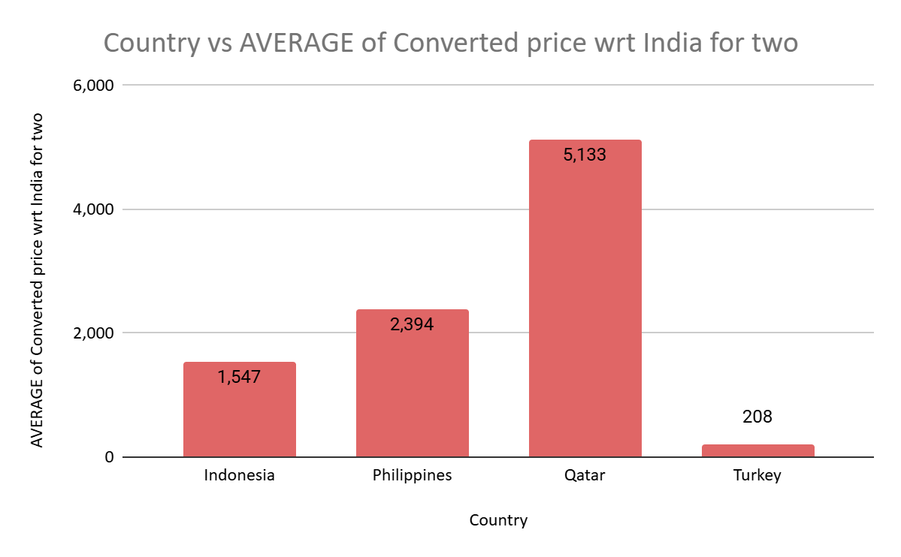

1. Come up with the names of restaurants from the recommended states that are our biggest competitors and also those that are rated in the lower brackets, i.e. 1-2 or 2-3.

Ans. **Approach Used**: The table below highlights restaurants with ratings between 3 and 5, categorized by color:

* **Light Blue**: These are our biggest competitors, with ratings between 4.5 and 5, indicating top performance.
* **Purple**: Represents restaurants in the lower bracket, with ratings between 3 and 4. These establishments may face challenges in customer satisfaction.
* **Yellow**: Restaurants rated between 4 and 4.5, which are also competitors, though not as significant as those rated 4.5 to 5.

**Insights**:

**Strong Competition**: The top competitors in each country have ratings between 4.5 and 5, showing high levels of customer satisfaction and loyalty. These restaurants offer varied cuisines and memorable experiences, positioning them as formidable competitors.

**Opportunities in Lower Brackets**: Restaurants with ratings between 3 and 4 present improvement opportunities, as they may face challenges related to service, food quality, or the overall dining experience.

**Recommendations**:

**Benchmarking Against Competitors**: Analyze the offerings, pricing, and customer service practices of top competitors to find ways to enhance your restaurant's unique value.

**Focus on Quality and Consistency**: Prioritize consistent food quality and service. Regular training for kitchen and service teams can help ensure customers enjoy a positive experience with each visit.

**Implement Customer Feedback Systems**: Establish strong feedback mechanisms through surveys, online reviews, and social media to better understand customer needs and address any pain points effectively.

| *Country* | *RestaurantName* | AVERAGE of Rating |
| --- | --- | --- |
| Indonesia | 3 Wise Monkeys | 4.2 |
|  | Avec Moi Restaurant and Bar | 4.3 |
|  | Fish Streat | 3.7 |
|  | Flip Burger | 4.4 |
|  | Lemongrass | 4 |
|  | Lucky Cat Coffee & Kitchen | 4.3 |
|  | Momo Milk | 3.7 |
|  | MONKS | 4.2 |
|  | Noah's Barn Coffeenery | 4.2 |
|  | OJJU | 3.9 |
|  | Onokabe | 3.7 |
|  | Satoo - Hotel Shangri-La | 4.6 |
|  | Skye | 4.1 |
|  | Sushi Masa | 4.9 |
|  | Talaga Sampireun | 4.9 |
|  | Toodz House | 4.6 |
|  | Union Deli | 4.6 |
|  | Zenbu | 4.4 |
| Philippines | Balay Dako | 4.5 |
|  | Buffet 101 | 4 |
|  | Cafe Arabelle | 3.6 |
|  | Din Tai Fung | 4.4 |
|  | Guevarra's | 4.2 |
|  | Heat - Edsa Shangri-La | 4.4 |
|  | Hobing Korean Dessert Cafe | 4.5 |
|  | Izakaya Kikufuji | 4.5 |
|  | Le Petit Souffle | 4.8 |
|  | Locavore | 4.8 |
|  | Mad Mark's Creamery & Good Eats | 4.2 |
|  | NIU by Vikings | 4.7 |
|  | Nonna's Pasta & Pizzeria | 4 |
|  | Ooma | 4.9 |
|  | Sambo Kojin | 4.8 |
|  | Silantro Fil-Mex | 4.85 |
|  | Sodam Korean Restaurant | 4.3 |
|  | Spiral - Sofitel Philippine Plaza Manila | 4.9 |
|  | The Food Hall by Todd English | 4.5 |
|  | Vikings | 4.2 |
|  | Wildflour Cafe + Bakery | 4.4 |
| Qatar | 7st by Mumbai Spices | 3.4 |
|  | Aalishan | 3.8 |
|  | Applebee's | 3.8 |
|  | Coral - InterContinental Doha | 3.7 |
|  | Eatopia | 3.9 |
|  | Gokul Gujarati Restaurant | 4.3 |
|  | Gymkhana | 4.7 |
|  | Indian Coffee House | 3.4 |
|  | Mainland China Restaurant | 4.9 |
|  | MRA Bakery Sweets & Restaurant | 4 |
|  | Paper Moon | 4.5 |
|  | Ponderosa | 3.6 |
|  | Punjab Restaurant | 3.8 |
|  | Roti & Boti | 3.9 |
|  | Sabai Thai - The Westin Doha Hotel & Spa | 4.3 |
|  | Texas Roadhouse | 4 |
|  | The Manhattan FISH MARKET | 4 |
|  | Vine - The St. Regis | 4.4 |
|  | Zaffran Dining Experience | 4.6 |
|  | Zaoq | 4.2 |
| Turkey | Aôôk Kahve | 4 |
|  | Baltazar | 4.3 |
|  | Cafemiz | 4.4 |
|  | Ceviz AÛôacÛ± | 4.2 |
|  | Dem Karakí_y | 4.5 |
|  | Dí_veroÛôlu | 4.3 |
|  | Draft Gastro Pub | 4.9 |
|  | Emirgan Sí_tiô | 4.2 |
|  | Gaga Manjero | 4.9 |
|  | Hattena Hatay SofrasÛ± | 4.6 |
|  | Huqqa | 3.7 |
|  | íˆukuraÛôa SofrasÛ± | 4.4 |
|  | J'adore Chocolatier | 4.7 |
|  | Karakí_y Gí_llí_oÛôlu | 4.7 |
|  | Kebap 49 | 4.3 |
|  | Leman Kí_ltí_r | 3.7 |
|  | Liva | 3.4 |
|  | MasabaôÛ± | 4.2 |
|  | MasabaôÛ± Kebapí_Û±sÛ± | 4.2 |
|  | Meôhur í_zí_elik Aspava | 4.6 |
|  | Meôhur TavacÛ± Recep Usta | 4.5 |
|  | NamlÛ± Gurme | 4.1 |
|  | Nusr-Et | 4.1 |
|  | Pizza ÛÁl Forno | 4.7 |
|  | Starbucks | 4.9 |
|  | The Bigos | 3.8 |
|  | Timboo Cafe | 4.2 |
|  | Turta Home Cafe | 4.3 |
|  | Valonia | 4.2 |
|  | Walter's Coffee Roastery | 4 |
|  | YÛ±ldÛ±z Aspava | 4.4 |
|  | Zigana Pide | 4.3 |

1. Which cuisines should we focus on in the newer restaurants to get better feedback? Does the choice of cuisines affect the restaurant ratings?

Ans. **Insights**:

**High-Performing Cuisines**:

**Sunda, Indonesian** and **Sushi, Japanese** cuisines have the highest average ratings (4.9), showing strong potential for customer satisfaction.

In the Philippines, **Filipino, Mexican** and **Japanese, Sushi** cuisines also top the charts (4.9), suggesting a growing preference for fusion and regional specialties.

**Café and Dessert Trends**:

Café-style dining, particularly combinations like **Cafe, Coffee and Tea, Western and Desserts, Bakery**, consistently scores well (around 4.6). This reflects a strong preference for casual dining that includes dessert options.

**Cuisines with Solid Ratings**:

Other cuisines, such as **European, Asian, and Indian** in the Philippines and **Chinese** in Qatar (each rated at 4.9), indicate interest in diverse options with regional influences.

**Underperforming Cuisines**:

Some cuisines, such as **Kebab and Turkish Pizza** in Turkey, have lower ratings (around 4.3-4.4). While these scores are still good, they suggest areas where innovation or quality improvements might be beneficial.

**Recommendations**:

**Focus on High-Rated Cuisines**:

Consider launching a restaurant specializing in **Sunda** or **Sushi**. These highly-rated cuisines could attract customers looking for unique and high-quality dining experiences.

Explore fusion dishes combining **Filipino and Japanese** elements to tap into their popularity and offer something new.

**Café Concept with Desserts**:

Establish a café that features a mix of **coffee, tea, and desserts**, blending popular Western and local flavors. Highlighting both local and international dessert options could broaden the café’s appeal.

**Experiment with Asian and International Cuisines**:

Introduce a menu that offers **Asian fusion** (e.g., combining Filipino and Japanese dishes) or a broader **international selection** to cater to a diverse audience and capitalize on high-performing cuisines.

**Market Testing for New Concepts**:

Before fully committing to a specific cuisine, consider testing new ideas through **pop-up events or food trucks**. This can help gauge customer interest and collect valuable feedback on high-potential concepts.

**Elevate Underperforming Cuisines**:

For cuisines like **Kebab or Turkish Pizza**, focus on enhancing quality and introducing unique recipes to improve customer satisfaction. Incorporating elements from higher-rated cuisines could also help boost their appeal.

| *Country* | *Cuisines* |
| --- | --- |
| Indonesia | Asian, Indonesian, Western |
|  | Burger |
|  | Cafe, Coffee and Tea, Western |
|  | Cafe, Italian, Coffee and Tea, Western, Indonesian |
|  | Cafe, Western |
|  | Desserts, Bakery, Western |
|  | French, Western |
|  | Italian, Continental |
|  | Japanese |
|  | Japanese, Sushi, Ramen |
|  | Peranakan, Indonesian |
|  | Seafood, Western |
|  | Sunda, Indonesian |
|  | Sushi, Japanese |
|  | Western, Asian, Cafe |
| Philippines | American, Asian, Italian, Seafood |
|  | American, Ice Cream, Desserts |
|  | Asian, European |
|  | Cafe, Bakery, American, Italian |
|  | Cafe, Korean, Desserts |
|  | Chinese |
|  | European, Asian, Indian |
|  | Filipino |
|  | Filipino, Mexican |
|  | French, Japanese, Desserts |
|  | Italian, Pizza |
|  | Japanese |
|  | Japanese, Korean |
|  | Japanese, Sushi |
|  | Korean |
|  | Seafood, American, Mediterranean, Japanese |
|  | Seafood, Asian, Filipino, Indian |
|  | Seafood, Filipino, Asian, European |
| Qatar | Chinese |
|  | Indian |
|  | International |
|  | Italian |
|  | Kerala, Indian, Chinese, Bakery |
|  | Pakistani |
|  | Seafood, American |
|  | Steak, American |
|  | Thai |
| Turkey | Bar Food |
|  | Burger, Izgara |
|  | Cafe |
|  | Cafe, Desserts |
|  | Desserts |
|  | Desserts, Bí_rek |
|  | Kebab |
|  | Kebab, Desserts, Turkish Pizza |
|  | Kebab, Izgara |
|  | Kebab, Turkish Pizza |
|  | Kebab, Turkish Pizza, Dí_ner |
|  | Pizza |
|  | Restaurant Cafe |
|  | Restaurant Cafe, Desserts |
|  | Restaurant Cafe, Turkish, Desserts |
|  | Steak |
|  | Turkish |
|  | Turkish Pizza |
|  | World Cuisine |
|  | World Cuisine, Mexican, Italian |
|  | World Cuisine, Patisserie, Cafe |

.

1. According to our current data, should we go for online delivery and table booking? Does that affect the customer’s ratings?

Ans. **Analysis of Online Delivery and Table Booking Impact on Ratings**

**Current Data Overview**:

**Online Delivery**:

**No Online Delivery**: 7,100 restaurants, average rating of 2.75.

**With Online Delivery**: 2,451 restaurants, average rating of 3.29.

**Table Booking**:

**No Table Booking**: 8,393 restaurants, average rating of 2.81.

**With Table Booking**: 1,158 restaurants, average rating of 3.48.

**Insights**:

**Higher Ratings for Delivery and Booking**: Restaurants that offer online delivery and table booking consistently show higher average ratings compared to those that do not.

**Market Gap**: There is a significant gap in the number of restaurants providing these services, suggesting an opportunity for new establishments to stand out by offering delivery and booking options.

**Recommendations**:

**Implement Online Delivery**: Since online delivery is associated with higher ratings, adding this service could attract more customers and improve overall ratings.

**Offer Table Booking**: Providing table booking options can increase convenience for customers, potentially boosting satisfaction and ratings in a market that values ease of access.

**Enhance Customer Engagement**: Establish strong feedback channels to continuously refine the delivery and booking experience. This can further improve ratings and build customer loyalty.

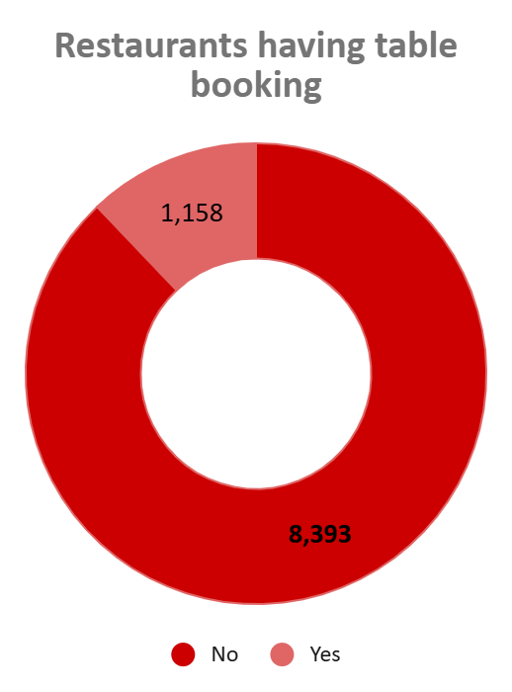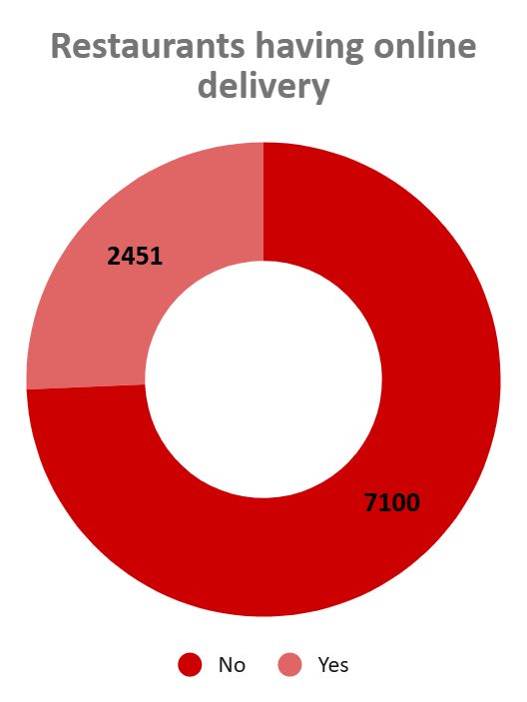

1. Should the team keep the rate of cuisines higher? Will that affect the feedback? According to our data are the rates of cuisines and ratings, correlated?

Ans.**Insights on Cuisine Pricing and Customer Ratings (Based on Correlation Coefficient: -0.6294)**

#### **Negative Correlation with Higher Prices:**

* The data shows a **strong negative correlation (-0.6294)** between cuisine pricing and customer ratings in the selected countries. This indicates that as prices increase, customer ratings tend to decrease.
* **Implication**: Customers in these regions are likely price-sensitive, and higher prices negatively impact their perception of value and satisfaction.

#### **Lower Ratings for Higher Price Ranges:**

* Higher-priced cuisines (above 1000) receive lower average ratings, suggesting that customers in these regions do not perceive the higher prices as justified by the quality or experience.
* Moderate price ranges (500–1000) show slightly better ratings, but the negative trend persists.
* **Key Insight**: Price increases may lead to dissatisfaction in these markets, unlike other regions where higher pricing correlates positively with ratings.

#### **Market Perception:**

* In the selected countries, customers may associate affordability with value for money, and higher prices with diminished satisfaction.
* This underscores the need to prioritize affordability and ensure that quality matches or exceeds customer expectations at every price point.

### **Recommendations**

#### **Avoid Price Increases:**

* **Action**: Refrain from raising prices for cuisines in the 500–1000 range or higher, as higher prices are likely to further reduce customer satisfaction.
* **Rationale**: The negative correlation suggests that customers in these regions are highly price-sensitive. Maintaining competitive pricing can help retain satisfaction and ratings.

#### **Focus on Quality at Affordable Prices:**

* **Action**: Improve the quality and presentation of dishes in the 0–500 price range, where customers expect higher value for their money.
* **Rationale**: Delivering superior quality at lower price points can help improve ratings and increase customer loyalty.

#### **Implement Targeted Pricing Strategies:**

* **Action**: Introduce a tiered pricing strategy to appeal to both price-sensitive and premium customers.

Offer affordable value meals for price-sensitive segments.

Provide premium options with enhanced experiences for customers willing to pay more.

* **Rationale**: Balancing affordability with premium offerings can capture diverse market segments without alienating customers.

#### **Enhance Feedback Systems:**

* **Action**: Launch a customer feedback system to monitor satisfaction levels across price tiers.
* **Rationale**: Regular feedback will help refine pricing and quality strategies to align with customer expectations.

### **Conclusion**

By focusing on affordability, improving quality in lower price ranges, and implementing tiered pricing strategies, the team can better align with customer expectations in these regions. Avoiding price increases while emphasizing value for money will help maintain and potentially improve customer satisfaction and ratings.

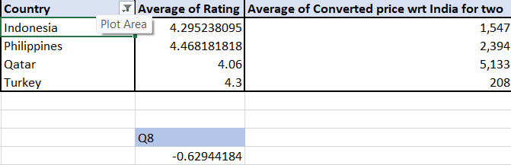

9.What is the distribution of the number of restaurants of different price ranges in all the countries?

Ans: **Insights on Restaurant Distribution by Price Range**

**Prevalence of Lower Price Ranges:**

**Price Range 1** dominates with 4,436 restaurants, highlighting a strong market presence for budget-friendly dining options.

**Price Range 2** also shows significant representation with 3,113 restaurants, indicating the popularity of mid-range dining establishments.

**Decline in Higher Price Ranges:**

There is a noticeable decrease in the number of restaurants in **Price Range 3** (1,408 restaurants) and **Price Range 4** (586 restaurants). This suggests a smaller market segment for high-end dining, possibly due to lower demand or fewer establishments catering to affluent customers.

**Market Opportunities:**

The abundance of lower-priced restaurants implies higher competition in these segments, while the fewer establishments in higher price ranges could present opportunities for new entrants or unique dining experiences.

### **Recommendations**

**Targeted Marketing for Higher Price Ranges:**

**Action:** Consider implementing marketing strategies to attract customers to Price Ranges 3 and 4, such as hosting special events, tastings, or exclusive menu offerings.

**Menu Innovation:**

**Action:** For restaurants in Price Ranges 3 and 4, explore diversifying the menu with unique, high-quality ingredients or themed dining experiences to attract more customers.

**Market Research:**

**Action:** Conduct surveys to understand consumer preferences and spending habits across different price ranges. This will provide valuable insights to help tailor offerings and meet customer demands.

| **Countrty_Name** | **1** | **2** | **3** | **4** |
| --- | --- | --- | --- | --- |
| Australia | 4 | 14 | 5 | 1 |
| Brazil | 2 | 7 | 16 | 35 |
| Canada |  | 3 |  | 1 |
| India | 4287 | 2858 | 1111 | 388 |
| Indonesia |  | 1 | 20 |  |
| New Zealand | 3 | 4 | 17 | 16 |
| Philippines |  | 1 | 12 | 9 |
| Qatar |  | 1 | 5 | 14 |
| Singapore |  | 1 | 5 | 14 |
| South Africa |  | 4 | 17 | 39 |
| Sri Lanka |  | 6 | 11 | 3 |
| Turkey |  | 11 | 18 | 5 |
| United Arab Emirates |  | 9 | 29 | 22 |
| United Kingdom | 4 | 28 | 32 | 16 |
| United States of America | 136 | 165 | 110 | 23 |
| Grand Total | 4436 | 3113 | 1408 | 586 |

10.Explain your approach in brief for suggesting countries/cities in order to open new restaurants, if the objective and subjective questions would have not been given to assist you. **[you have to give bullet pointers in order to answer this question].**

Ans.

**Data Review for Quality:**Begin by checking the dataset for missing or inconsistent information, such as missing restaurant names or incorrect geographical coordinates.

**Data Cleaning:**Clean the data by correcting or removing inaccurate values to ensure a reliable analysis.

**Restaurant Count per Country:**Calculate the total number of restaurants in each country to identify market saturation.

**Restaurants per Capita:**If population data is available, calculate restaurant density by comparing the number of restaurants to the population to better assess market opportunities.

**Customer Ratings & Votes:**Analyze average customer ratings and the number of votes to gauge overall customer satisfaction and interest in the market.

**Popular Cuisines:**Identify the most popular cuisines in different countries or cities, and tailor the expansion strategy to align with local preferences.

**Price Range Distribution:**Examine the distribution of price ranges to understand which markets are more price-sensitive and adjust offerings accordingly.

**Average Cost for Two:**Compare average dining costs across countries to assess affordability and local purchasing power.

**Existing Restaurant Presence:**Look for cities or countries with fewer restaurants or market gaps, indicating underserved areas with growth potential.

**Online Delivery and Table Booking Penetration:**Identify regions where these services are less common, presenting an opportunity for Zomato to stand out by offering them.

**Geographical Considerations:**Target cities with strategic significance, such as tourist hotspots or major business centers.

**Cross-Comparison of Factors:**Combine data on restaurant density, price sensitivity, customer satisfaction, and competitor presence to pinpoint the most promising countries and cities.

**Focus on Emerging Markets:**Prioritize expansion in emerging markets where there is growing economic development and increasing demand for food services.